Mrs. Husna Matin
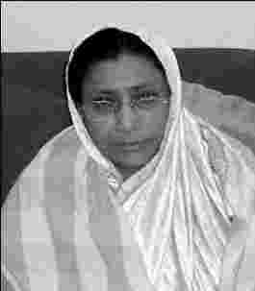

Mrs. Husna Matin
Interview date: 30 _ Jan _ 06
Interviewed by: Jamil Iqbal and Ansar Ahmed Ullah
A remarkable woman, who was not afraid to confront racist skinheads. In one incident she risked her life and ran after some skinheads with sticks in her hand. This happened after the skinheads attacked an elderly Bengali and his son.

Q: Tell us, where you were at wartime, and your experiences of the independent war.
MHM: My husband was working in Pakistan embassy, in Saudi Arabia before the war. From Saudi Arabia we came to Pakistan that is the West Pakistan, and shortly, in about one month, the war started. We were very worried and anxious, because I had three young daughters. Police were guarding all our (Bengali) homes (in Islamabad, Pakistan) it seemed to us that they were watching us. They have not treated us badly (within the embassy compound), but I was scared about my husband, as he was leaving the home in the morning, we had no assurance that he will return at evening, we were afraid of his life.
We were scared going out wearing our Bengali dress. We did not wear Sarees for four five months, we wore salwar and kamiz, so that they couldn’t recognize us on the streets, if we were Pakistani or Bengali.
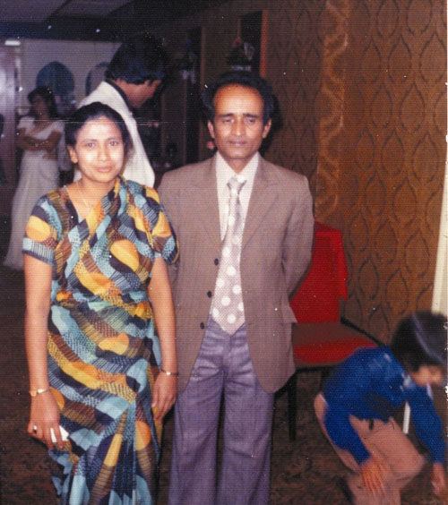
We could not collect our belongings that were sent from Saudi Arabia, bound to Karachi. We were not thinking of our goods sent from Saudi Arabia, rather we were thinking, how to flee West Pakistan, with our lives. We were scared to listen to the radio, we listened to the broadcast, hiding the radio and taking it near the ears, and lowering the volume, and we were afraid of our life, and always afraid of attack on us.
One of our well-wishers, within the office compound helped us very much, he helped us getting out of West Pakistan. We applied for umra (pilgrimage) visa and went to Saudi Arabia, we left our goods that possibly reached at Karachi seaport at that time. We came to Karachi from Islamabad, we tried to go to one of my cousin’s home, who was a navy officer, but the security forces didn’t allow us. So we stayed at a hotel near Karachi, the next day we got our visa and on the third day flew to Saudi Arabia.
When we reached Saudi Arabia, my husband went to visit his office that is the Pakistan embassy at Saudi Arabia. They arrested him with the false allegation of connection with India. Some of his colleagues working in the embassy helped him and they assured his innocence, and he was released and was kept in the embassy compound. After independence, Bangladesh authority got us out of the compound, and neither the Saudi Arabia, nor the Pakistan authority accepted us. At the very beginning Bangladesh had no diplomatic tie with Saudi Arabia. India sent a ship to take back the Hajjees, who were visiting Saudi Arabia at that time for Hajj. That ship took us, the 17 families who were in the Pakistan embassy, doctor, nurse and other staff, to Bangladesh. It took 17 days to reach Bangladesh.
We were due to come to Bangladesh on 26th March 1971, we had our ticket confirmed for that date. We went to Pakistan in February from Saudi Arabia, and we had our ticket confirmed on 26th. But my children got pox in the meantime and so we changed our ticket. The family that bought the tickets and returned East Pakistan were killed by the Pakistani army. All the passengers of that flight were killed. We were due to be on the flight.
In Pakistan we suddenly found our home surrounded by the police. We were afraid of life. We had a four band radio, we mainly listen to BBC, VOA and radio China, with huge precaution. We feared that they will be following us from the outside. We were five Bengali families in that building.
We came to Bangladesh, after 3months of independence. We came to Chittagong by a ship. We raised the Bangladesh flag in the ship in March. My children sang the song Amar Sonar Bangla, on the top of the ship. We were informed that the country has been liberated. That produced more trouble for us. The Saudi Arabia government had not recognised Bangladesh
We arrived at Chittagong seaport, but as we arrived there was a low tide so we had to wait another day in the sea for high tide. The custom officers didn’t check us, they left us telling that, Pakistan has destroyed everything in Bangladesh, if you have brought anything that is yours.
We met Mr Moinuddin in Chittagong, he came to receive us hearing the news of our arrival. He showed us the situation in Chittagong. We saw big craters on the surface, which were made by bombings. We were in Chittagong for four days, and then we left Chittagong for Dhaka by air. We were also in financial crises.
After reaching Dhaka, we stayed at the residence of the governor of the state bank, Ijazur Rahman, who was my cousin. The next day my husband went to the foreign secretariat. They told him, all who have returned from different foreign missions of Pakistan, will be provided with their jobs again, but for the next few weeks we have to wait for further notice.
We then came to Sylhet, but we were financially broke, and my cousin helped us. As we were coming to Sylhet, we were unaware of the condition of our homes. We hired a car from the airport, but the car was unable to reach our home, as the roads were badly damaged by bombs. There had been a huge fight between the Pakistani soldiers themselves, (friendly fire) near our home, during the war. People at home were disconnected from us in the long nine-months, so they were very glad to see us alive and safe again. We stayed at home for two weeks, and then again we came to Dhaka, my husband worked at Dhaka for nine months, and then he was transferred to London. We suffered a lot when we were staying at Bangladesh at that period. We had not enough food, no pure drinking water and no milk for the children, we suffered a lot. There was shortage of essential goods in the market and the prices were very high. At that time we were staying at Dhaka.
In 1974 we all (my children & myself) came to London, and shortly in 1975 we suffered another problem. We lost seven years of saving which my husband earned in Saudi Arabia.
We first came to Surrey and stayed there for one year. And in 1975 we came to London. My husband worked for seven years with the Bangladesh high commission here in UK, and then he left the job. We came to East London on 1976.
Racism in UK in 1980s: In the end of 1976, the skinhead problem started in the UK. There was a lot of Jews around this area. The skinheads gave us a very hard time. The Bengali men were afraid of going out in the late evening. They were troubling the women less, but were attacking the Bengali men. The skinheads used to beat the Bengali men and loot whatever they had on them whenever there was a chance.
Gradually the Pakistani, Indian and the Bangladeshi youths started to form small organisations. They fought back the skinheads. There was big Jewish population around our street. The Jews dominated businesses here in East London. They were the owner of shops. The Jews started to leave the area, and Bengalis started to move into East London.
Q: Can you remember any of the specific incidents of fighting here during the skinheads trouble?
MHM: Yes I can. One evening, this incident took place in front of our house at Varden Street. One of my neighbours, who lived in house no 30, coming back from London Mosque was assaulted by the skinheads. The skinheads physically attacked both father and son. They were screaming for help, we got out of our house, my daughters got out and took some steel rod and started running towards the scene. The skinheads ran away, leaving the victims, very badly injured. After that police came, we threw our rods on the street, we were afraid of being arrested.
We had no telephone in the area. Someone would have to go to New Road to make a call and you don’t know if you will back home safely. The skinheads attacked many Bengalis on their way back from telephone booths.
Mr. Altab Ali was killed in 1978, and some other people known to us were assaulted at that time. We avoided going out at night. In case of an emergency, like to make a phone call, we never went alone, some one used to accompany me. After that we took a telephone connection in my house. We suffered a lot, it is easy to say now but it was not that easy to face reality then. We lived in this dilapidated house for 14 long years. The house was not properly ventilated and in the winter, chilling air entering the house. There was a shortage of houses in the area. In the early 80s the authority offered us to choose our own house, we were afraid to move from here fearing of the skinheads. The houses were taken under the GLC and we gave them rent for few years, the rent was £10 for our house. The GLC offered us to sign a contract with them, so that they will pull down the old houses and provide us with new houses in the same road. There were twelve houses in this road, they made it eight. So finally we got our own house. One of the main problems we faced during the late 70s and early 80s was to have a bath. One had to go to bath once a week. We usually bathed on a Saturday going to some public bath.
Q: Was there any organisation of the Bengalis here?
MHM: We had no Bangladeshi organisation before 1977, but we with the leadership of Lily Khan, formed an organisation in Myrdle Street School. I worked as a volunteer. We arranged a language class for the Bangladeshi women. The organisation still exists.
Q: When did the skinhead leave this area?
MHM: Skinhead problem was over in 1980-81. Our people started to get organised and started to defend themselves. Slowly they broke up and the problem was solved. We got establish in Britain after 1981. Peter Shore came to my home many times. They (Bengali community activists) had a hostel in Tower Hill, I used to go there if they had any programme and I used to cook for them.
Q: Please tell us about Altab Ali murder and the impact it had?
MHM: Altab Ali was killed by the skinheads. That was the starting point for the Bangladeshis to get organised. We formed some committees to protect the Bangladeshis.
The Bangladesh Welfare Organisation was established in 1971, and all the people had a common meeting place in our home. We had only one mosque in the whole East London that was situated in a tiny house near the cinema hall, which is no more there. It is converted into car parking space. Then it was transferred to another place, where all the Bangladeshis from all over the UK, used to gather especially during the EID. From 1985-87 people started to build mosques all over Britain. Every thing has improved now, but we had so gloomy houses in this area that people were not even interested to look at those. We used to fear of getting attacked. We rarely looked at someone while crossing roads, there was the possibility of getting hit by the skinheads. We used to look at the ground when crossing them.
Q: Can you mention about the women organisation?
I think the first Bengali women organisation was established here in the UK. We used to meet in the organisation and we had our language classes here from 1977. It was due to the courage Lily Khan that we had a women organisation in East London. They went to different places and formed different organisations. Mrs Hasan is one who formed an organisation. Women have more facilities to learn English now. We have classes in Jagonari but women are not coming out. (Delwar Hossain) Sayedi (fundamentalist Jamaat leader (has spoiled the new generation women. They are not willing to learn English.
Q: Are you involved in any party now?
I am involved with Jagonari, involved in their management. We have three exercise classes every week. Women get some financial supports from Jagonari as well. The young women are benefiting from this financial support.
Q: How did Terry Fitzpatrick and other White people helped you? Did he inspire you to form an organisation for the Bengali people?
Terry helped us a lot. Farrukh Dhondy from India was with him. He helped us getting electricity connection or water supply connection or things like that. He used to earn some money by helping people.
We supported Labour Party all these years, but after the Iraq war we have left Labour. We are in Lib-Dem now. We have not voted for Labour Party because they have attacked Iraq. We need a Bengali MP now.

